Segmentation of Shops by   
Median Household Income   
in Metro Vancouver

Coursera Capstone Final Report

Bingbing (Krystal) Zhang

November 30, 2020

Table of Contents

Introduction 3

Background 3

Problem 3

Interest 3

Data 4

Data Source 4

Data Cleaning 4

Feature Selection 4

Methodology 5

Results 7

Discussion 8

Conclusion 10

# Introduction

## Background

Metro Vancouver is a concept of a specific region near and include Vancouver, British Columbia, Canada. Metro Vancouver has a wide range of shops selections as well as a very diverse culture and races compositions. Like similar metropolis across the world, Metro Vancouver’s residents work in a large number of different sectors and industries and have a wide band of income levels.

## Problem

There is always interest in finding out the impact of income levels on different consumer sectors especially like shops.

Finding out the distribution and relationship between their income levels and shops categories can be greatly helpful in determining the profile of shops industries and providing an overview of the income level’s impact on this industry as well.

## Interest

Since the author has been lived in Metro Vancouver area for more than 7 years, it is in great interest of the author to be able to find and visualize the pattern of shops in different sub-areas in Metro Vancouver. Also, Coursera provided author essential knowledge and tools to make this happen.

# Data

## Data Source

This report will discuss the results of shops segmentation work produced by using a wide range of data sources including 2016 Canada Census Profile, Canada Post, Foursquare Places API etc.

To be specific, the data is retrieved from the following places in Public Domain:

1. 2016 Canada Census Profile: Statistics Canada Website
2. Canada Post: There is no direct data interaction. However, its Forward Sorting Area code is used to separate regions in the 2016 Canada Census Profile. Forward Sorting Area (FSA) is a trademark controlled by Canada Post
3. Foursquare Places API: The shops categories and relevant profiles will be retrieved from Foursquare Places API.
4. Geolocation Services Canada API: The API will be used to find the centroid coordinates of each FSA

## Data Cleaning

Most data we use in this project is in decent shapes and formats. As a result, there is no extensive data cleaning necessary in this project.

Some minor filtering and joining of data will be handled by the Jupyter Notebook discussed later in this report.

## Feature Selection

The report will use the following fields in respective data sources detailed in the following table:

|  |  |  |
| --- | --- | --- |
| Data Source | Fields | Notes |
| 2016 Canada Census Profile | Median Household Income | Income information |
|  | Forward Sorting Area | FSA used as a way to determine elements in segmentation process |
| Foursquare Places API | Category Name | Name of Category |
| Geolocation Services Canada API | Coordinates | Coordinates of each FSA’s centroid |

# Methodology

The report will use the output from a Python Jupyter Notebook that was developed during this process. Unless stated otherwise, all the data using in the Notebook is from Public Domain and are restricted by their copyright agreement.

Several Python packages will used:

* Pandas
* Requests
* Sklearn
* Folium

Basically, the Notebook is a data processing pipeline that involves multiple steps and stages. The Notebook calls a number of API services followed by the ETL process, and then use the sklearn’s KMeans clustering method in grouping the neighbourhoods (or FSA, more specifically).

For a high-level illustration, the flowchart on next page can be a great reference:

# Results

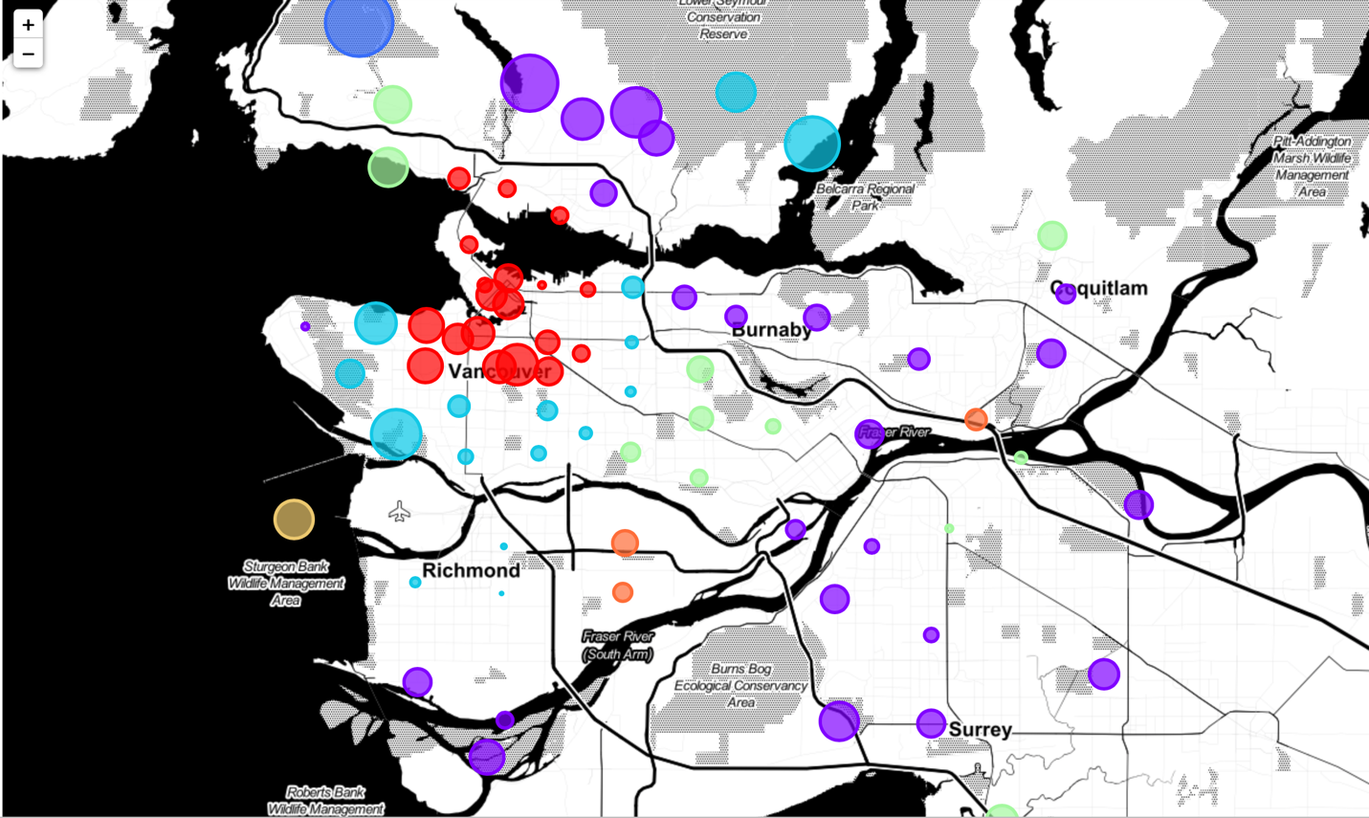

As you could see from the result above, the popular shops categories show an obvious pattern in Metro Vancouver.

The colour of the bubble is the Cluster of neighbourhoods that have similar categories of shops in popularity. The size of the bubble represents the normalized scale of income, the bigger the bubble, the higher median household income present.

# Discussion

When we examine each cluster with different label (colour), there are quite different in distribution of shops categories.

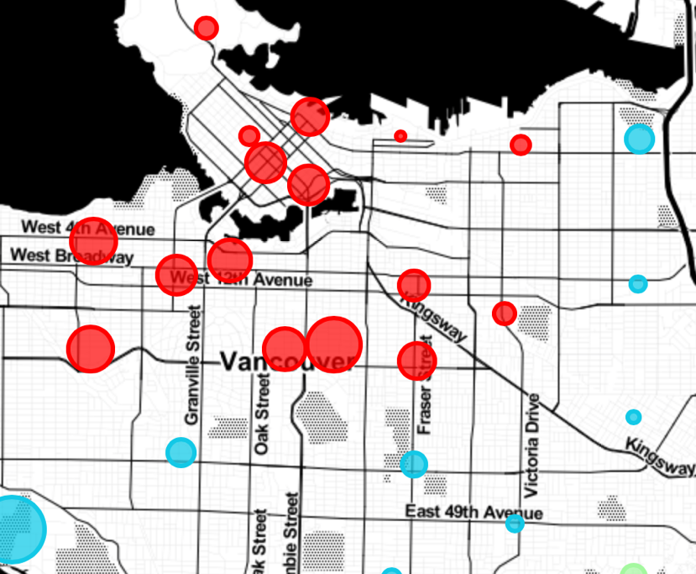

For example, the most common shops in the red cluster which is at the centre-right of the map above are:

* Grocery Store
* Apparel
* Pharmacy
* Liquor Store

And the average median household income in that cluster is approximately $95407 CAD which is much higher than the national average ($88306).

As you can see, the overall average of yellow bubble size is significantly larger than the other parts which means the households in that area have higher income. This shows a clear impact on their shopping choices. The Apparel and Liquor Store usually set a relatively high price points that are more approachable by higher income households.

On the contrast, when looking into the green cluster on the east part of Metro Vancouver:

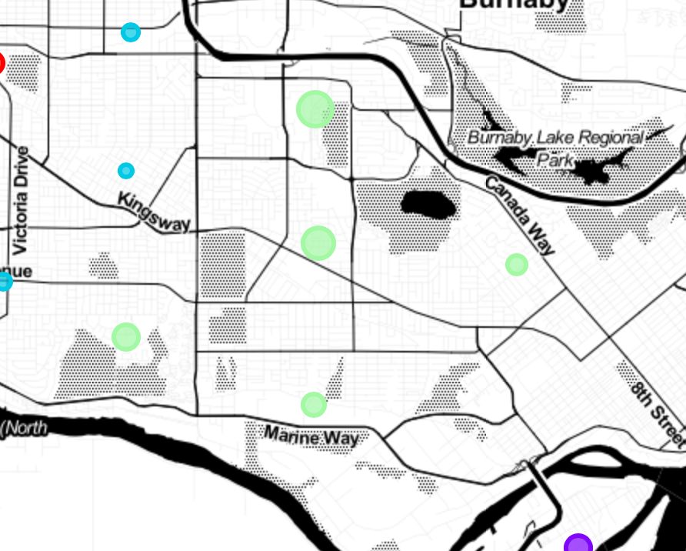

The most common shops in this region are quite different from the red cluster we discussed above; the common shops are now:

* Big Box Store
* Supermarket
* Discount Store

These are relatively more affordable places compare with the shops in red cluster. This is also supported by the average median household income of $91936 which is about 5% lower than the red cluster.

# Conclusion

To sum up, this project shows an interesting outcome that the popular shops in an area is very closely connected with its income level. The higher average household income area generally contains a more expensive or luxury set of shops like Seafood, French etc.

One important thing needs to be mentioned is that the household size can also be a noise factor in the income data. For instance, the blue cluster above in east part of Metro Vancouver may have more large families with 5-6 people while the red cluster may have 3-4 instead. This can pose a huge effect on the available funds to dine out and eventually result in different food choices.

However, the effect on popular shops is not just from the household income. It may consist multiple factors like culture, race etc. Due to the time and computation restraints, it is not a highly comprehensive analysis and there is a long way to go for a more solid conclusion.

As a future direction, segmentation of shops like this need analysis on more independent variables and should be based on more data. This obviously requires deeper understanding of data analytics field and expertise in relevant fields.